AM/AOA/19-20/35 Date: - 23.01.2020
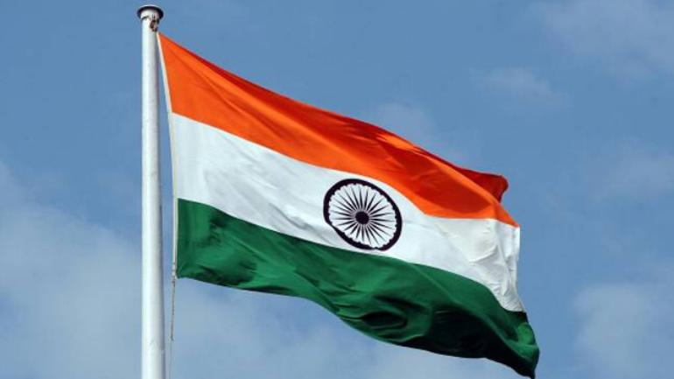
HAPPY REPUBLIC DAY
Dear Residents,
On the auspicious occasion of Republic Day & in line with earlier celebrations; AMAOA is organizing to celebrate the day on Sunday the 26th January 2020 as per schedule given here under.
Flag Hoisting | 9:45 A.M.
Cultural Activities | 10:15 A.M. Onwards
Light Refreshment with Tea | 11:00 A.M.
Sports Activities | 11:30 A.M.
Prize distribution | At the end of fun filled Sports Activities
VENUE | BADMINTON COURT
Residents are humbly requested to converge at the venue for Flag Hoisting and participating in cultural & sports activities at the scheduled time & venue.

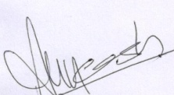

(Secretary)
(Angel mercury Apartment Owner’s Association)

